**PIZZZA SALE SQL QUERIES**

**1 . KPI :-**

**1 .Total_Revenue :**

**SELECT SUM(total_price) AS Total_Revenue FROM pizza_sales ;**

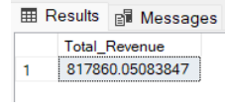

**2. Avg_Order :**

**SELECT SUM(total_price) / COUNT(DISTINCT order_id) AS Avg_order FROM pizza_sales ;**

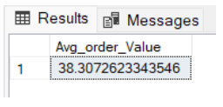

**3. Total_Pizza_sold**

**SELECT SUM( quantity) AS Total_pizza_sold FROM pizza_sales ;**

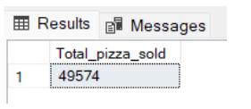

**4. Total_Orders**

**SELECT COUNT(DISTINCT order_id ) AS Total_Oder FROM pizza_sales ;**

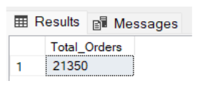

**5. Avg_Pizza_Per_Order :**

**SELECT CAST(SUM(quantity) / COUNT(DISTINCT order_id) AS DECIMAL (10 , 2)) AS Avg_Pizza_per_Order FROM Pizza_sales ;**

